**Books Qurey :**

insert into Books value (1,"Let Us C","Yashvant P. Kanetkar",200.00), (2,"Thinking In Java","Thinking In Java",300.00), (3,"Computer Networking","James F. Kurose",250.00), (4,"Head First C#","Andrew Stellman",400.00), (5,"What is HTML5?","Brett McLaughlin",300.00), (6,"HTML in Action","Joe Lennon",569.00), (7,"OOP with C++","Balagurusamy",308.00), (8,"C++:The Complete Reference","Herbert Schildt",532.00), (9,"Head First SQL","Lynn Beighley",450.00), (10,"SQl:The Complete Reference","James Groff",667.00);

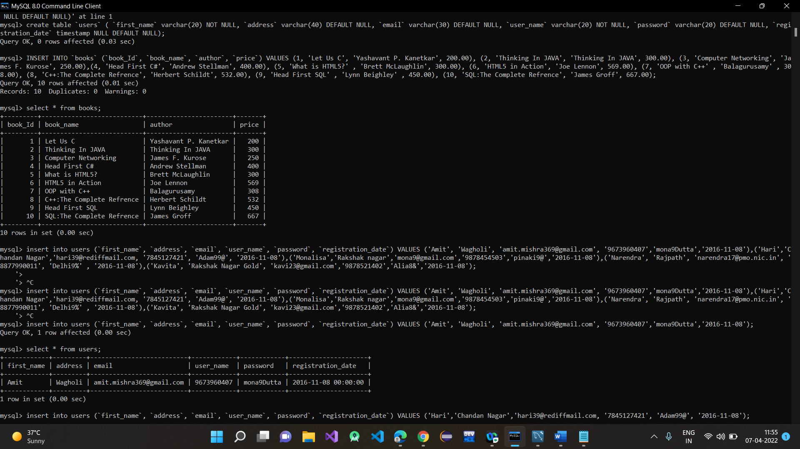

**Users :**

insert into Users value("Amit","Wagholi","amit.mishrea369@gmail.com","587458692","mona9Dutta","2016-11-08"),

("Hari","Chandan Nagar","hari39@rediffmail.com","554820692","Adam99@","2016-11-08"),("Monalisa","Rakshak Nagar","mona9@gmail.com","554820692","pinaki9@","2016-11-08"),

("Narendra","Rajpath","narendra8@pmo.nic.in","789820692","Delhi9%","2016-11-08"),("Kavita","Rakshak Nagar Gold","kavi23@gmail.com","586810692","Alia8&","2016-11-08");

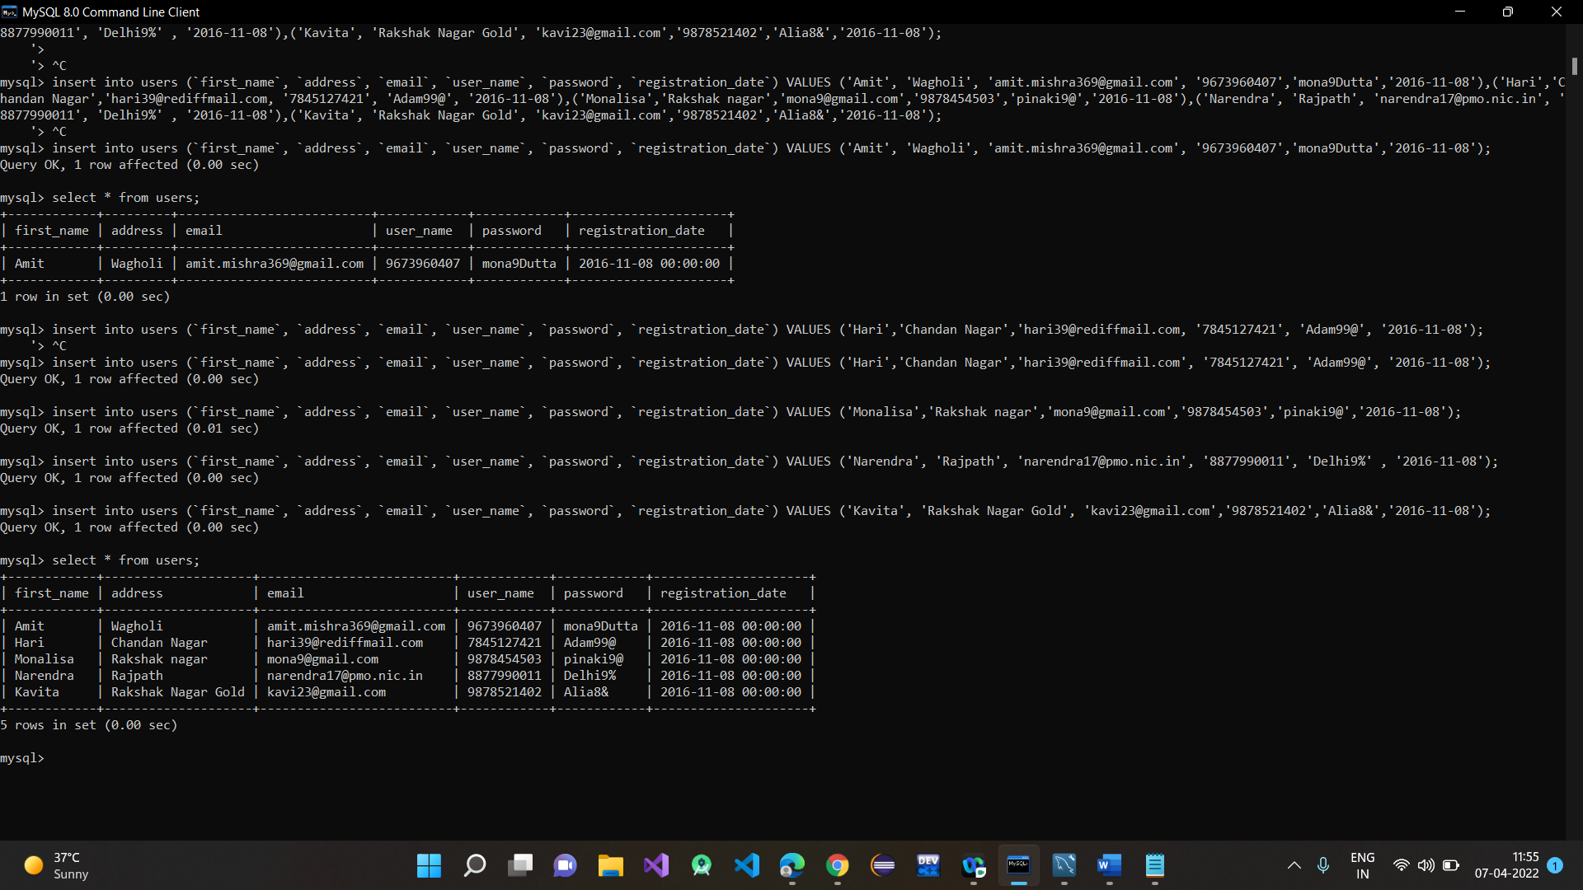

**Order-details :**

insert into Order_Details value(1,2,"Amit","124563875","Radhika Vihar","2015-11-08","3"),(2,4,"Mona","758457521","Rakshak Nagar","2016-11-08","3"),(3,3,"Kavi","578469528","Rakshak Nagar Gold","2016-11-08","2"),(4,3,"Monalisa","854578654","Banglore","2016-11-08","3"),(5,6,"Amol","854578654","Wadganosheri","2016-11-08","3"),(6,2,"Amit","124563875","Banglore","2015-11-08","2");

